

AP® Physics C
1992 Free response Questions

The materials included in these files are intended for use by AP teachers for course and exam preparation in the classroom; permission for any other use must be sought from the Advanced Placement Program®. Teachers may reproduce them, in whole or in part, in limited quantities, for face-to-face teaching purposes but may not mass distribute the materials, electronically or otherwise. These materials and any copies made of them may not be resold, and the copyright notices must be retained as they appear here. This permission does not apply to any third-party copyrights contained herein.

These materials were produced by Educational Testing Service® (ETS®), which develops and administers the examinations of the Advanced Placement
Program for the College Board. The College Board and Educational Testing Service (ETS) are dedicated to the principle of equal opportunity, and their
programs, services, and employment policies are guided by that principle.

The College Board is a national nonprofit membership association dedicated to preparing, inspiring, and connecting students to college and opportunity.
Founded in 1900, the association is composed of more than 4,200 schools, colleges, universities, and other educational organizations. Each year, the
College Board serves over three million students and their parents, 22,000 high schools, and 3,500 colleges, through major programs and services in
college admission, guidance, assessment, financial aid, enrollment, and teaching and learning. Among its best-known programs are the SAT®, the
PSAT/NMSQT®, and the Advanced Placement Program® (AP®). The College Board is committed to the principles of equity and
excellence, and that commitment is embodied in all of its programs, services, activities, and concerns.

APIEL is a trademark owned by the College Entrance Examination Board. PSAT/NMSQT is a registered trademark jointly owned by the College Entrance Examination Board and the National Merit Scholarship Corporation. Educational Testing Service and ETS are registered trademarks of Educational Testing Service.
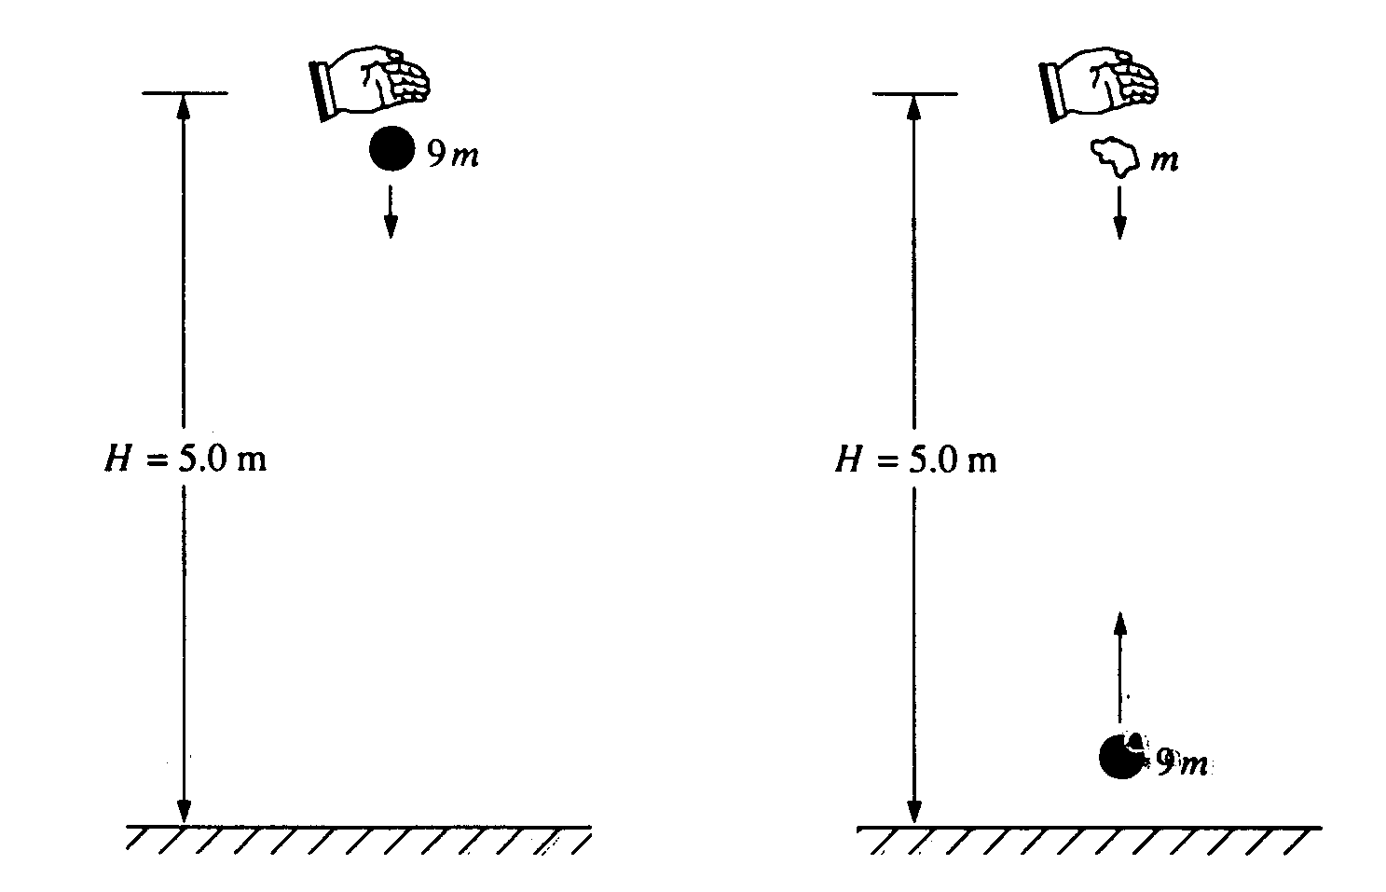
1992M1. A ball of mass 9m is dropped from rest from a height H = 5.0 meters above the ground, as shown above on the left. It undergoes a perfectly elastic collision with the ground and rebounds. At the instant that the ball rebounds, a small blob of clay of mass m is released from rest from the original height H, directly above the ball, as shown above on the right. The clay blob, which is descending, eventually collides with the ball, which is ascending. Assume that g = 10 m/s², that air resistance is negligible, and that the collision process takes negligible time.
a. Determine the speed of the ball immediately before it hits the ground.
b. Determine the time after the release of the clay blob at which the collision takes place.
c. Determine the height above the ground at which the collision takes place.
d. Determine the speeds of the ball and the clay blob immediately before the collision.
e. If the ball and the clay blob stick together on impact, what is the magnitude and direction of their velocity immediately after the collision?
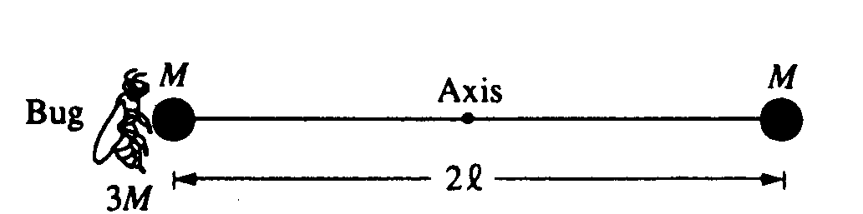
1992M2. Two identical spheres, each of mass M and negligible radius, are fastened to opposite ends of a rod of negligible mass and length 2l. This system is initially at rest with the rod horizontal, as shown above, and is free to rotate about a frictionless, horizontal axis through the center of the rod and perpendicular to the plane of the page. A bug, of mass 3M, lands gently on the sphere on the left. Assume that the size of the bug is small compared to the length of the rod. Express your answers to all parts of the question in terms of M, l, and physical constants.
a. Determine the torque about the axis immediately after the bug lands on the sphere.
b. Determine the angular acceleration of the rod-spheres-bug system immediately after the bug lands.

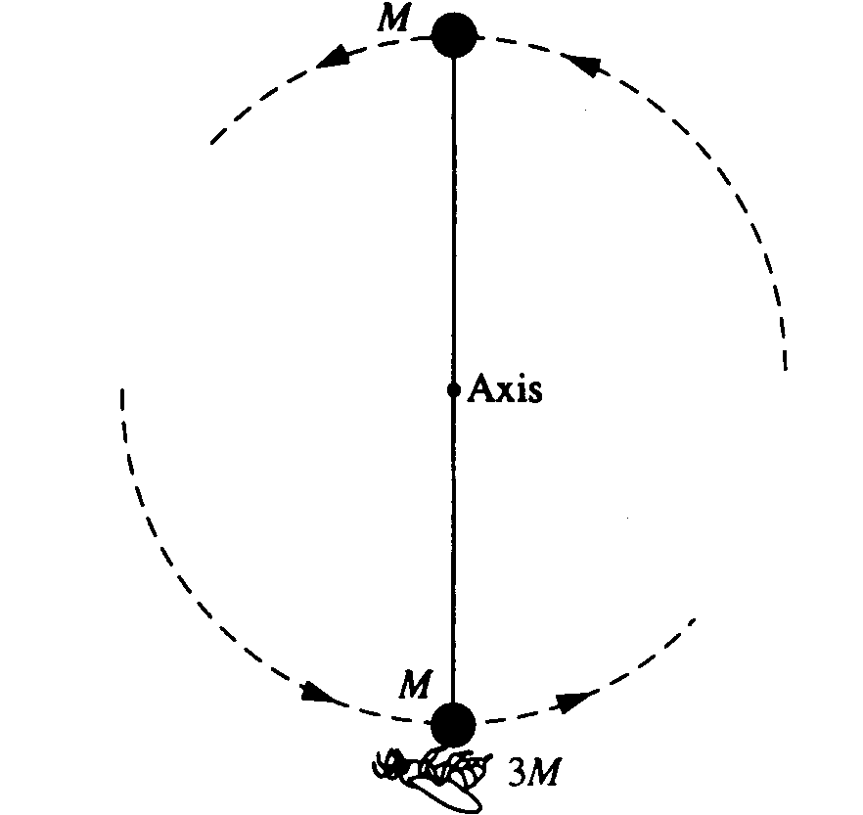

The rod-spheres-bug system swings about the axis. At the instant that the rod is vertical, as shown above, determine each of the following.
c. The angular speed of the bug
d. The angular momentum of the system
e. The magnitude and direction of the force that must be exerted on the bug by the sphere to keep the bug from being thrown off the sphere
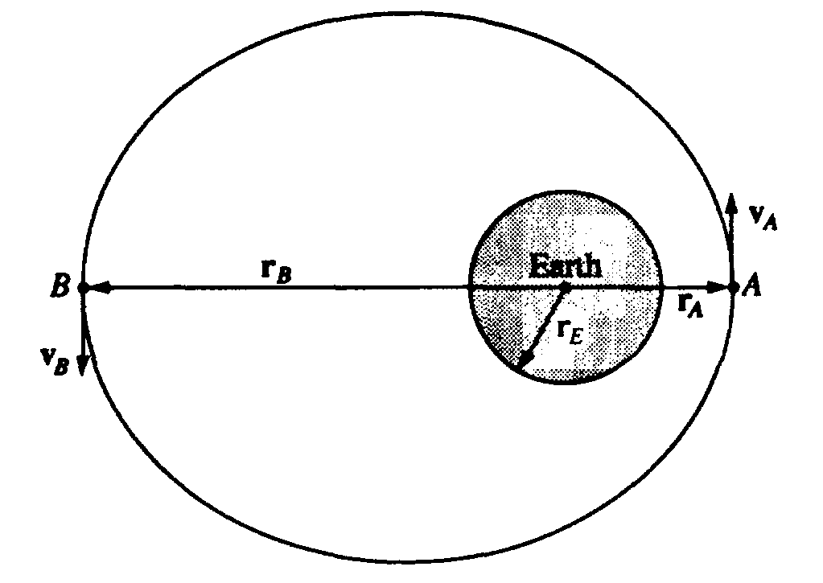
1992M3. A spacecraft of mass 1,000 kilograms is in an elliptical orbit about the Earth, as shown above. At point A the spacecraft is at a distance r_{A} = 1.2 x 10⁷ meters from the center of the Earth and its velocity, of magnitude V_{A} = 7.1 x 10³ meters per second, is perpendicular to the line connecting the center of the Earth to the spacecraft. The mass and radius of the Earth are M_{E} = 6.0 X 10²⁴ kilograms and r_{E} = 6.4 X 10⁶ meters, respectively.
Determine each of the following for the spacecraft when it is at point A .
a. The total mechanical energy of the spacecraft, assuming that the gravitational potential energy is zero at an infinite distance from the Earth.
b. The magnitude of the angular momentum of the spacecraft about the center of the Earth.

Later the spacecraft is at point B on the exact opposite side of the orbit at a distance r_{B} = 3.6 X 10⁷ meters from the center of the Earth.
c. Determine the speed v_{B} of the spacecraft at point B.

Suppose that a different spacecraft is at point A, a distance r_{A} = 1.2 X 10⁷ meters from the center of the Earth. Determine each of the following.
d. The speed of the spacecraft if it is in a circular orbit around the Earth
e. The minimum speed of the spacecraft at point A if it is to escape completely from the Earth
1992E1. A positive charge distribution exists within a nonconducting spherical region of radius a. The volume charge density ρ is not uniform but varies with the distance r from the center of the spherical charge distribution, according to the relationship ρ = βr for O < r < a, where β is a positive constant, and ρ=O, for r >a.
a. Show that the total charge Q in the spherical region of radius a is βπa⁴
b. In terms of β, r, a, and fundamental constants, determine the magnitude of the electric field at a point a distance r from the center of the spherical charge distribution for each of the following cases.
i. r > a ii. r =a iii. O < r <a
c. In terms of β, a, and fundamental constants, determine the electric potential at a point a distance r from the center of the spherical charge distribution for each of the following cases.
i. r =a ii. r = 0

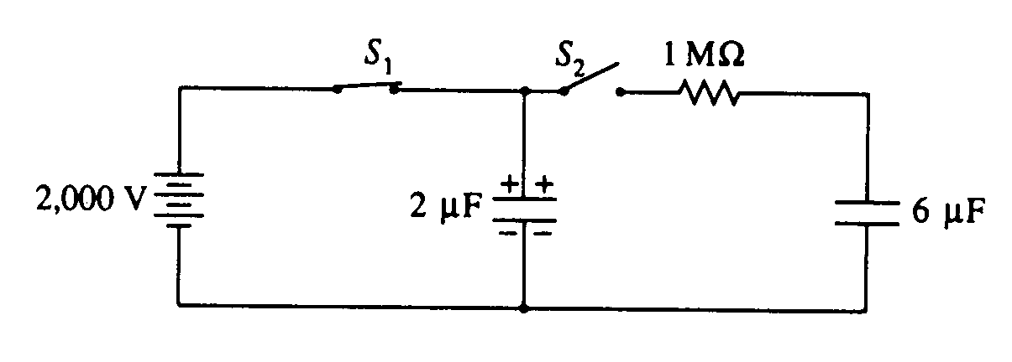
1992E2. The 2-microfarad (2 x l0⁻⁶ farad) capacitor shown in the circuit above is fully charged by closing switch S₁ and keeping switch S₂ open, thus connecting the capacitor to the 2,000-volt power supply.
a. Determine each of the following for this fully charged capacitor.
i. The magnitude of the charge on each plate of the capacitor.
ii. The electrical energy stored in the capacitor.

At a later time, switch S₁ is opened. Switch S₂ is then closed, connecting the charged 2-microfarad capacitor to a l-megohm (1 x 10⁶ Ω) resistor and a 6-microfarad capacitor, which is initially uncharged.
b. Determine the initial current in the resistor the instant after switch S₂ is closed.

Equilibrium is reached after a long period of time.
c. Determine the charge on the positive plate of each of the capacitors at equilibrium.
d. Determine the total electrical energy stored in the two capacitors at equilibrium. If the energy is greater than the energy determined in part (a) ii., where did the increase come from? If the energy is less than the energy determined in part (a) ii., where did the electrical energy go?

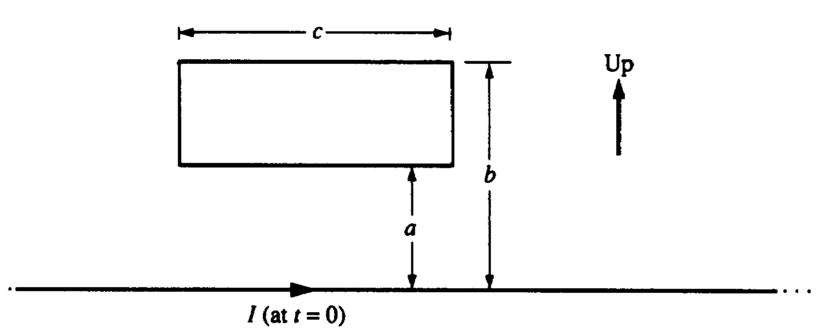
1992E3. The rectangular wire loop shown above has length c, width (b - a), and resistance R. It is placed in the plane of the page near a long straight wire, also in the plane of the page. The long wire carries a time-dependent current I = α(1 -βt), where α and β are positive constants and t is time.
a. What is the direction of the magnetic field inside the loop due to the current I in the long wire at t=0?
b. In terms of a, b, c, α, β and fundamental constants, determine the following.
i. An expression for the magnitude of the magnetic flux through the loop as a function of t.
ii. The magnitude of the induced emf in the loop.
c. Show on the diagrams below the directions of the induced current in the loop for each of the following cases.

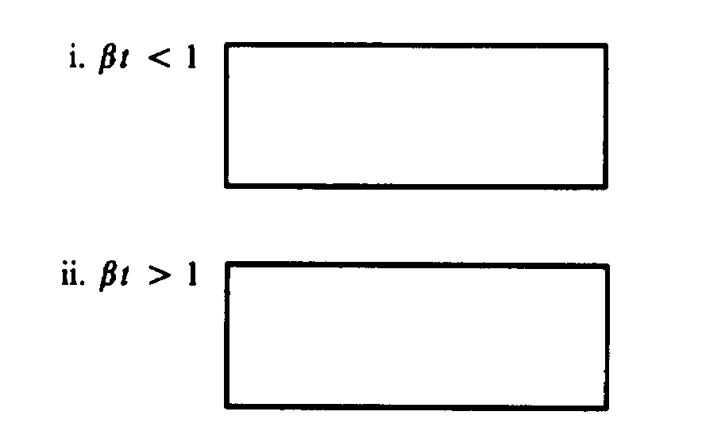
d. What is the direction of the net force, if any, on the loop due to the induced current at t = 0 ?

